DBMS Lab
Assignement No: 01

Name: Jay Kotwal
Roll No: 32137

SQL Commands:
1) Show Databases:
--SHOW DATABASES;

+--------------------+----
| Database
+--------------------+----
| 32137db |
| information_schema |
| performance_schema |
+--------------------+

2) Creating database:
-- CREATE DATABASES dbName;

3) Use Database:
-- USE DATABASE DbName;

4) Table Creation:
--CREATE TABLE DbName ( name data_type Constraints);

CREATE TABLE student
(
name varchar(50),
rollno int,
branch varchar(10)
);

5) Inserting Values in the Table:
--INSERT INTO Table_Name VALUES
(------,--------,--------),
INSERT INTO student values
("JAY",1,"entc"),
("OM",2,"aids"),
("SANKET",3,"COMP")

6) Showing Tables:
--SHOW TABLES;
7) Describe the Table:
--DESC TABLE;
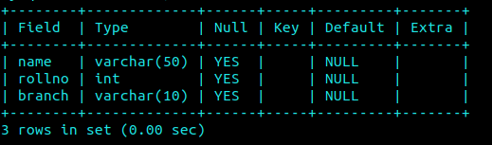
8) Select columns from table/Show table:
--SELECT * FROM Dbname;
--SELECT name FROM DbName;
